Now we will use our understanding of common accounting transactions that we learned in Section 1.4 to complete an accounting transactions grid.

### Interactive Exercise

1. Complete the accounting transactions grid for the $4,000 investment transaction below.



1. Complete the accounting transactions grid for the following transactions related to sales to customers

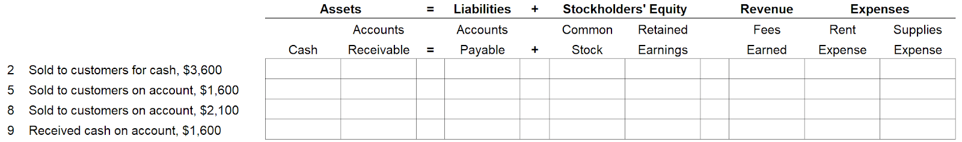

1. Complete the accounting transactions grid for the following transactions related to purchases from vendors.

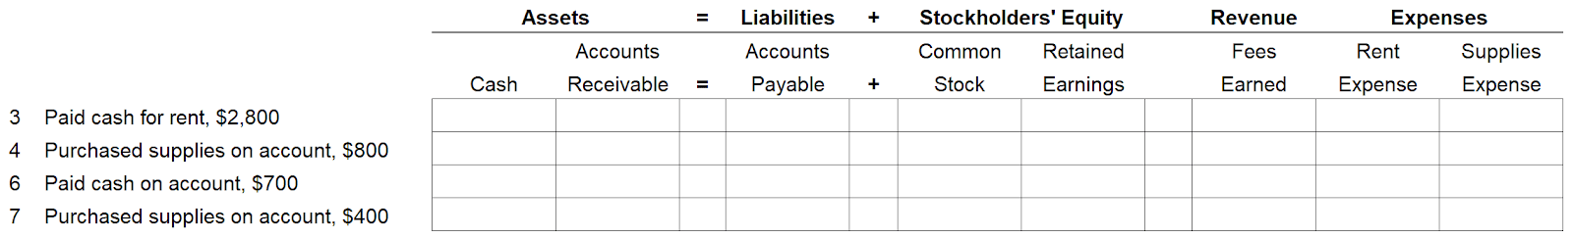

1. The following accounting transactions grid summarizes your entries from the previous three parts. Enter the totals for each account column in the last row.

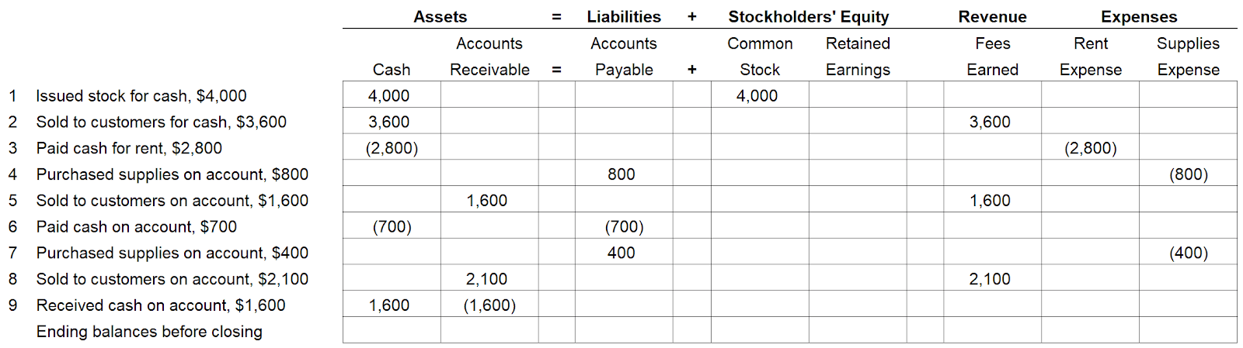

1. Based on the correct entries for part 4, complete the closing entries and ending balances after closing.

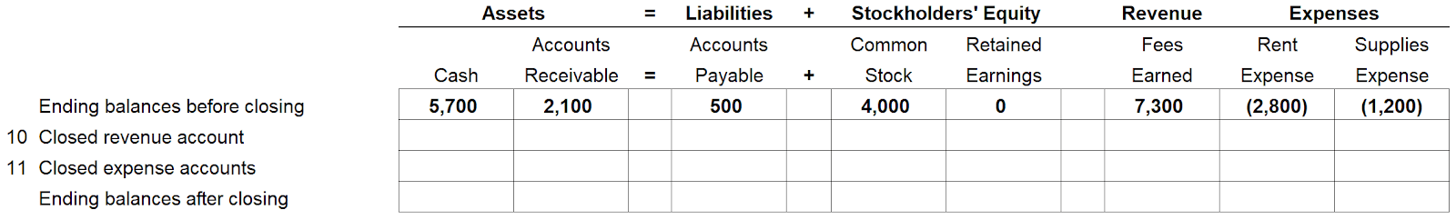

**The following grid shows an aggregated picture of all the transactions just completed.**

